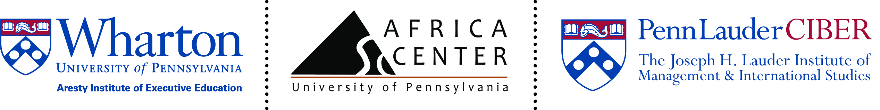

Global Business Strategy: University of Ghana EMBA Day at Wharton
February 18th, 2014

8:00am Registration and Continental breakfast (First Floor Foyer)
8:45am - 9:00am Group Photo (Yasuda Amphitheater, 2nd floor)
9:00am - 9:30am: Welcome and Introductions: (First Floor Amphitheater)
- Wendy McGeehan, Practice Leader, Education, Public and Social Sectors, Aresty Institute of Executive Education, The Wharton School
- Anastasia, Shown, MSW, Assistant Director, Africa Center, University of Pennsylvania
- Kenric Tsethlikai, Ph.D.Managing Director |The Lauder Institute | Penn Lauder CIBER
- Monica McGrath, Vice Dean, Aresty Institute of Executive Education, Adjunct Assistant Professor, Management, The Wharton School
9:30am -9:45am: Break (First Floor Foyer)
9:45am-11:45am: (First Floor Amphitheater)
Private Equity in Emerging Markets with Steve Sammut
In this session, participants will learn to identify and manage special issues when investing or partnering with companies based in rapidly growing economies. They will also become familiar with methods of due diligence and valuation, as well as liquidity and investment terms. Additionally, the session will address the structuring of funds, compensation, and the calculation of returns and will provide a review of past performance.

11:45am -12:00pm: Break (First Floor Foyer)
12:00pm – 12:30pm: Campus Tour
12:30pm – 1:30pm: Lunch (Zellen Dining Room, Vance Hall)
1:30pm – 2:00pm: (First Floor Amphitheater)
Cross-cultural Business Recommendations with Anastasia Shown
In today’s business environment, the ability to communicate effectively across geographies and cultures is increasingly important. We will discuss some of the key differences in Ghana and U.S. work culture and explore face-to-face vs. virtual culture, leadership culture, gender norms, dress and office etiquette. Real life examples of cultural mishaps and role plays will educate and entertain.

2:00pm – 2:45 pm (First Floor Amphitheater)
Panel Discussion facilitated by Marton Markovits
Novel Initiatives and New Impact: UPenn Student Efforts in Africa
Panelists: Melissa Cecilia Blohm, Fana Gibson, and Alhaji F. Saccoh

2:45pm – 3:00pm: Break (First Floor Foyer)
3:00 pm – 4:30 pm: (First Floor Amphitheater)
Formulating Strategy with Dr. Harbir Singh
Given the conditions of our increasingly complex and rapidly-changing business environment, companies must learn to re-frame traditional views on achieving competitive advantage and developing strategy. This session takes an in-depth look at these changes and explores new views on competitive advantage and strategy formulation.

4:30 pm – 5:30pm: Closing
- Dr. Carol Muller Professor of Music and Director, Africa Center, School of Arts and Science University of Pennsylvania.
Presentation of Certificates and Gifts
5:30pm -6:30pm Reception and Remarks (Saul Lobby, Second Floor)
Performance by the New Spirit of Penn Gospel Choir
http://www.dolphin.upenn.edu/nspirit/index.html
Remarks by:

Katherine Klein, Edward H. Bowman Professor of Management, Vice-Dean, Wharton Social Impact Initiative
- Tamela Vieira, Managing Director, Custom Programs, Aresty Institute of Executive Education, The Wharton School

